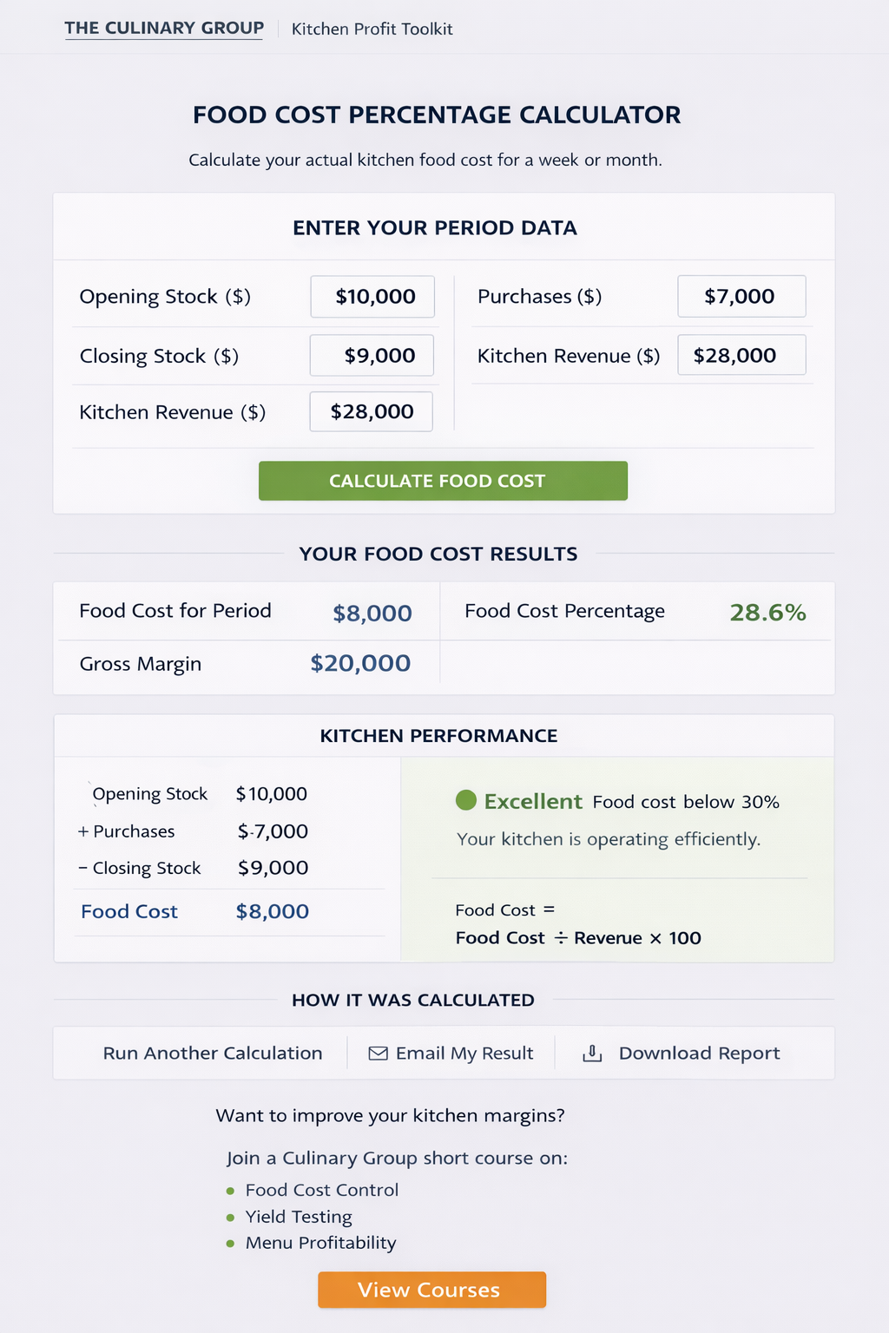
$30,800
Total Sales
Total sales /1.1

